TASK 1 — Linux IP Investigation
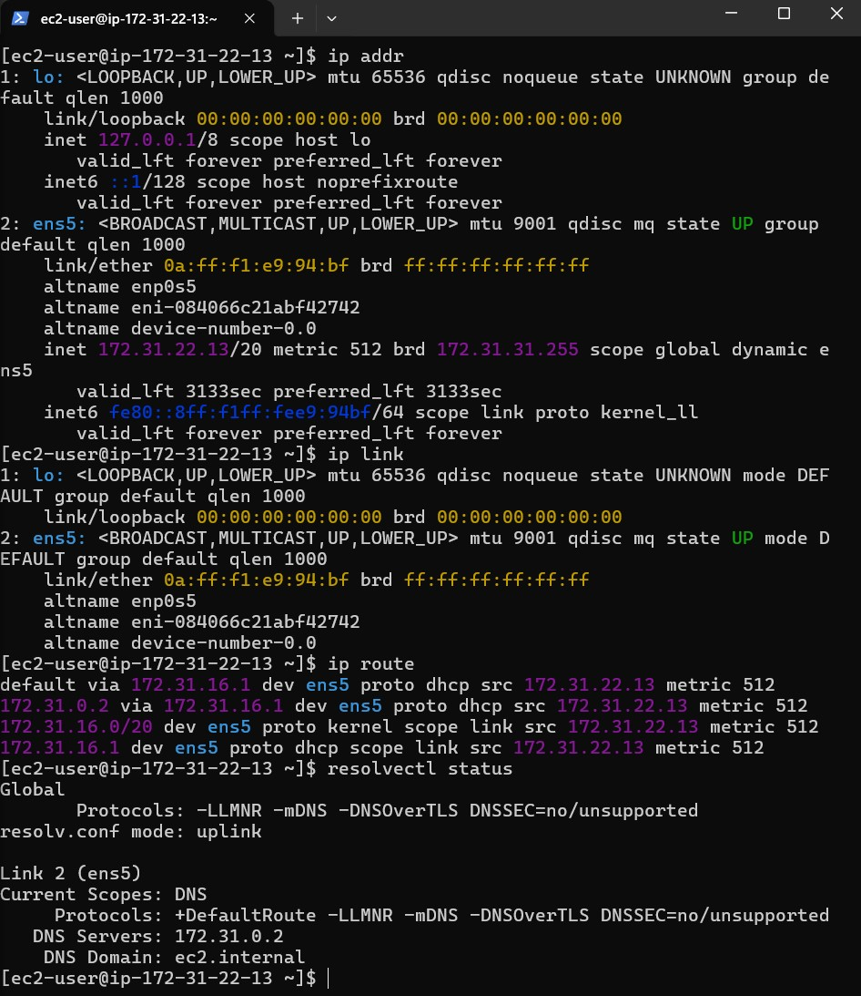
TASK COMMAND USE RESULTS
Find Ip Address Ip addr Ip=127.0.0.1
Find interface Ip link Network interface : ens5
Find gateway Ip route Default Gateway : 172.31.16.1
Find interface Resolvenctl status DNS server : 172.31.0.2
TASK 2 — IPv4 Address Analysis

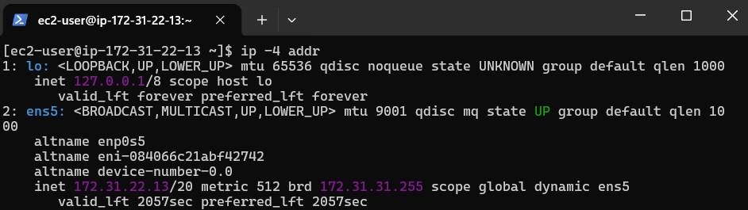
IPv4 address : 172.31.22.13
-Identify the IPv4 address and separate it into its four octets.
Octet | Value
1st | 172
2nd | 31
3rd | 22
4th | 13
-Determine whether the IP is private or public.
Private IPv4 Address Ranges
10.0.0.0 – 10.255.255.255
172.16.0.0 – 172.31.255.255
192.168.0.0 – 192.168.255.255
Is a private IP address because it falls within
172.16.0.0 – 172.31.255.255

-Network/host Information.
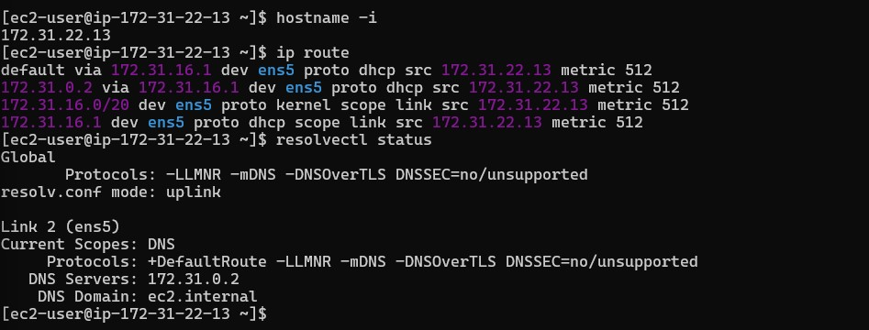
Task Command Results
Check hostname hoatname -I 172.31.22.13
Check network information ip route

-Find the IP address of at least two other devices or systems accessible from your environment and compare their addresses.
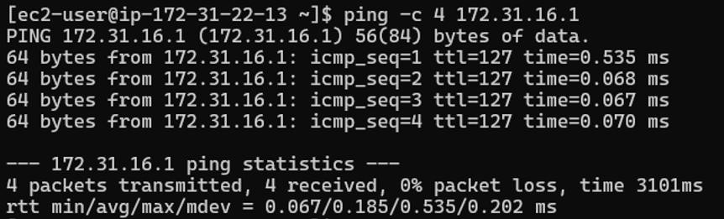
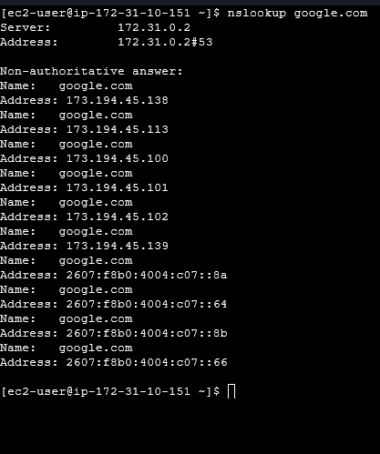
System | IPv4 Address | Type
EC2 | 172.31.22.13 | Private
Default Gateway | 172.31.16.1 | Private
Google | 64.233.180.138 | Private

TASK 3 — Dynamic IP Investigation
Record the current IP address.

Check the IP address again.

Before disconnect → IP Address: 54.204.206.198
After reconnect → IP Address: 3.80.155.62

TASK 4 — Cloud Linux Server & IP -Create a AWS EC2 Linux instance.
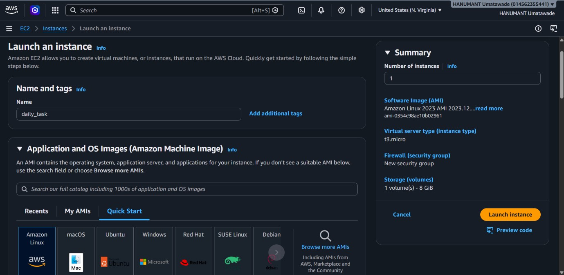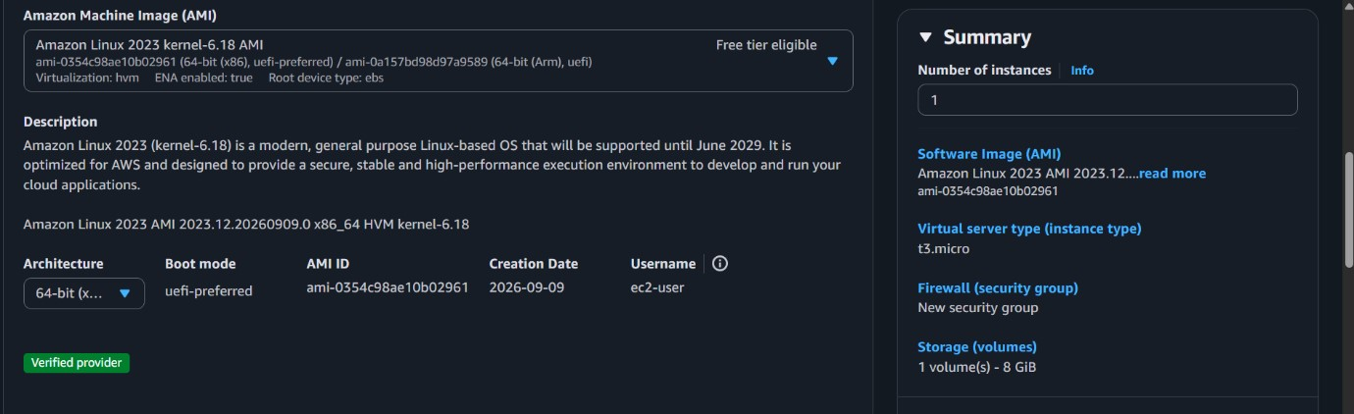
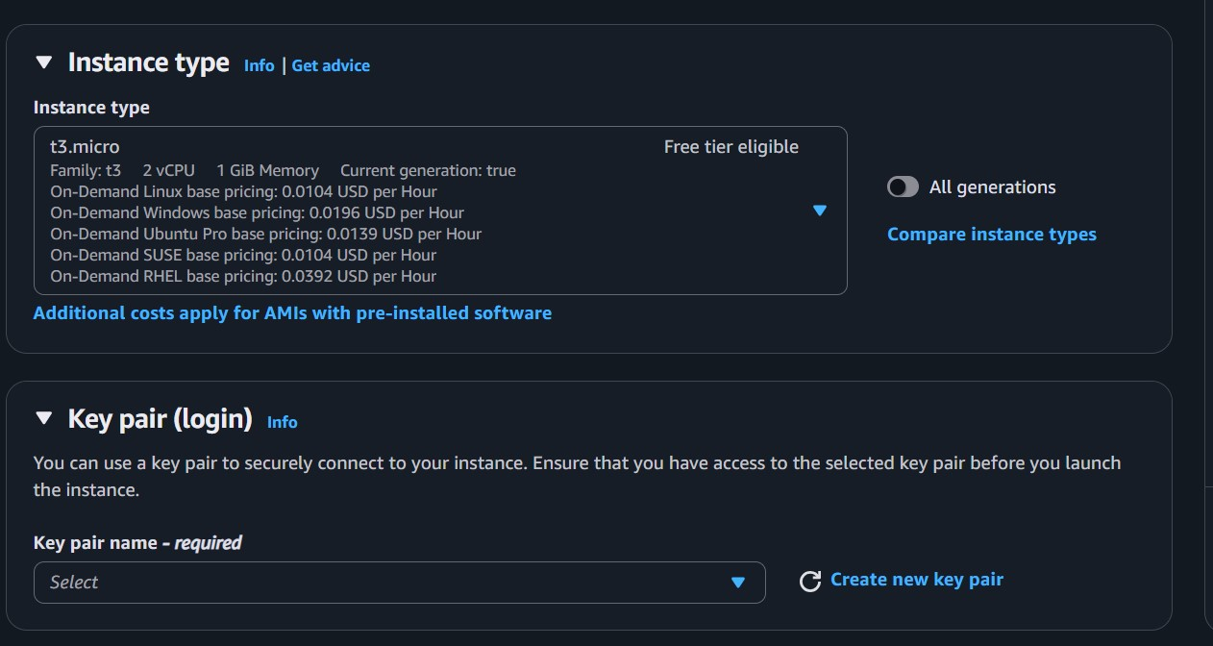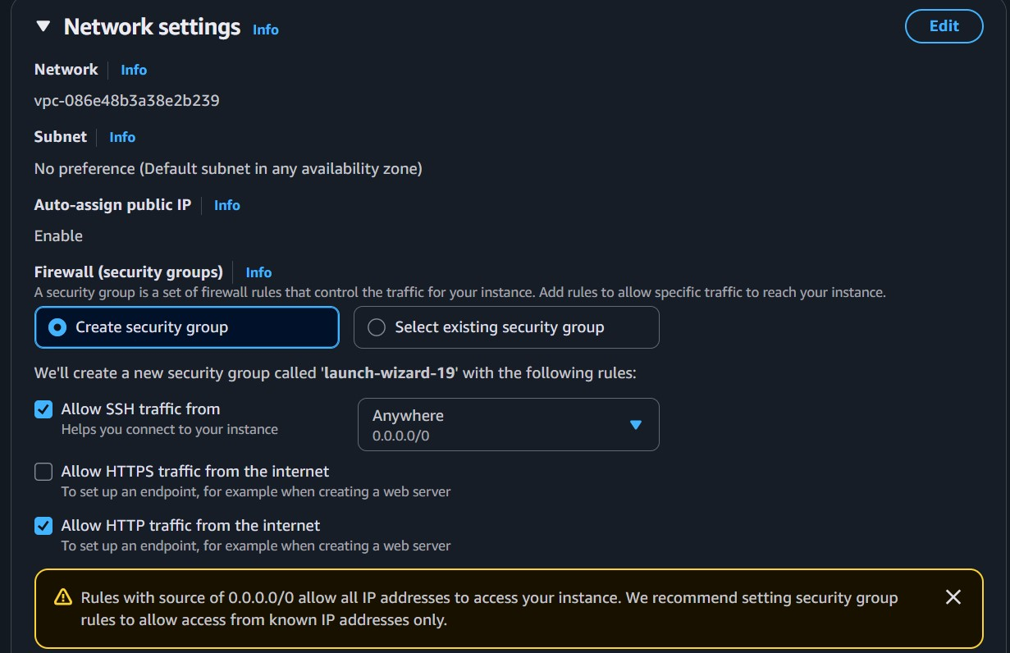
Tab launch instance to create ec2 server -Connect to the VM using SSH.
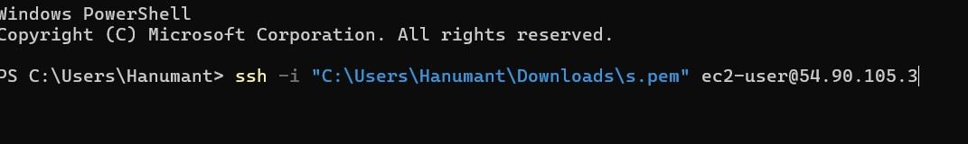

Find its private IP from inside Linux.
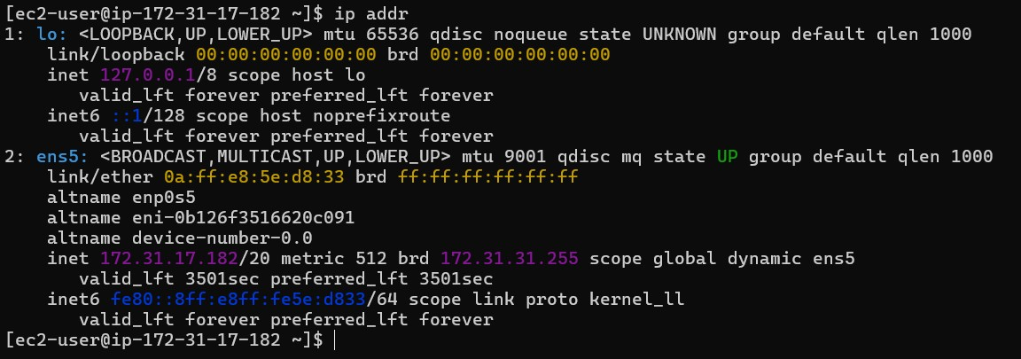
Private ip = 127.0.0.1

-Find its public IP.
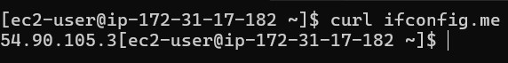
Public ip = 54.90.105.3
-showing successful SSH access
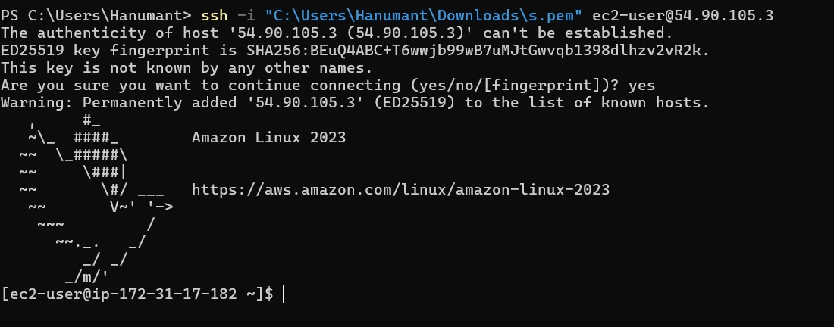
VM's IP configuration.

TASK 5 — Cloud Network Troubleshooting
-Check the IP address.
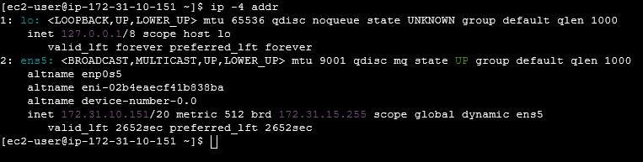
-Check the network interface.

Check the default route.
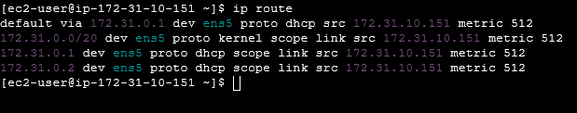

-Check network connectivity.
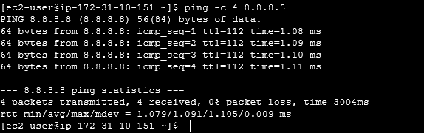

-Check running services.

Start nginx service

Check nginx status

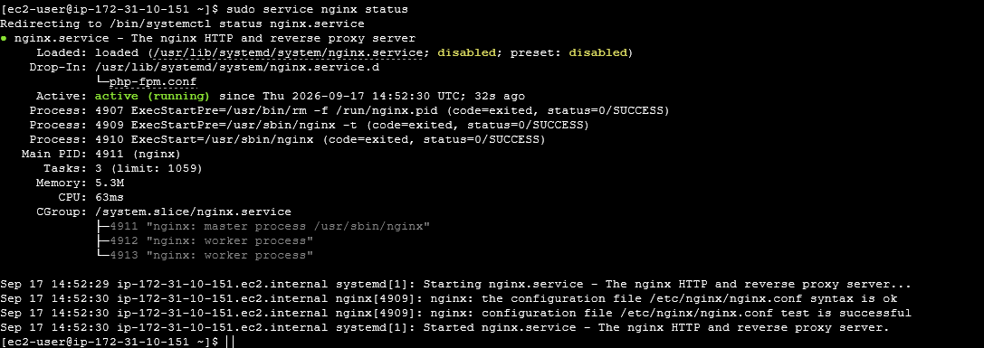

-Check listening ports.
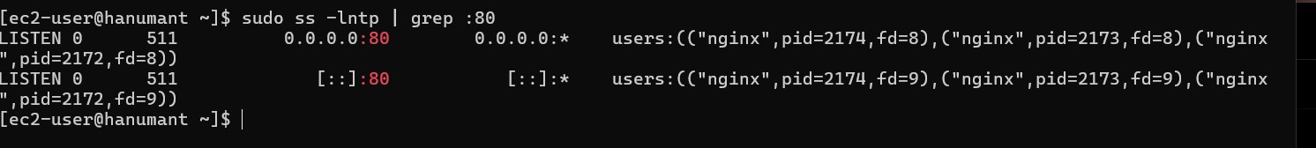
-Check firewall/security rules.
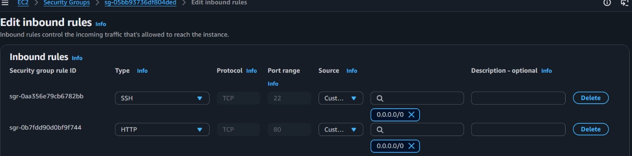
Problem: Nginx service was stopped.
Cause: Nginx was not running ( sudo systemctl start nginx ).
Final Result: Nginx is running and listening on port 80, and the website is accessible through the EC2 public IP.
Local test
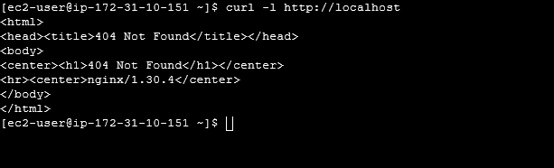

Step Command Output Result
IP ip -4 addr 172.31.29.255 IP available
Step | Command Output Result
Interface | ip link ens5 up Interface working
Route | ip route default via Route available
Connectivity | ping -c 4 8.8.8.8 4 packets received Network working
Service | Sudo service nginx status inactive | Problem found
Port | sudo ss -lntp | grep :80 LISTEN :80 | Port open locally
AWS Security | Security Group HTTP 80 allowed | External access allowed
Local test | curl -I localhost 200 OK | Service working
Fix | sudo systemctl start nginx Service started | Fixed

